Video referred : <https://youtu.be/RzrIqzC9bQc>

<https://phoenixnap.com/kb/how-to-install-nginx-on-ubuntu-20-04>

Installing NGINX

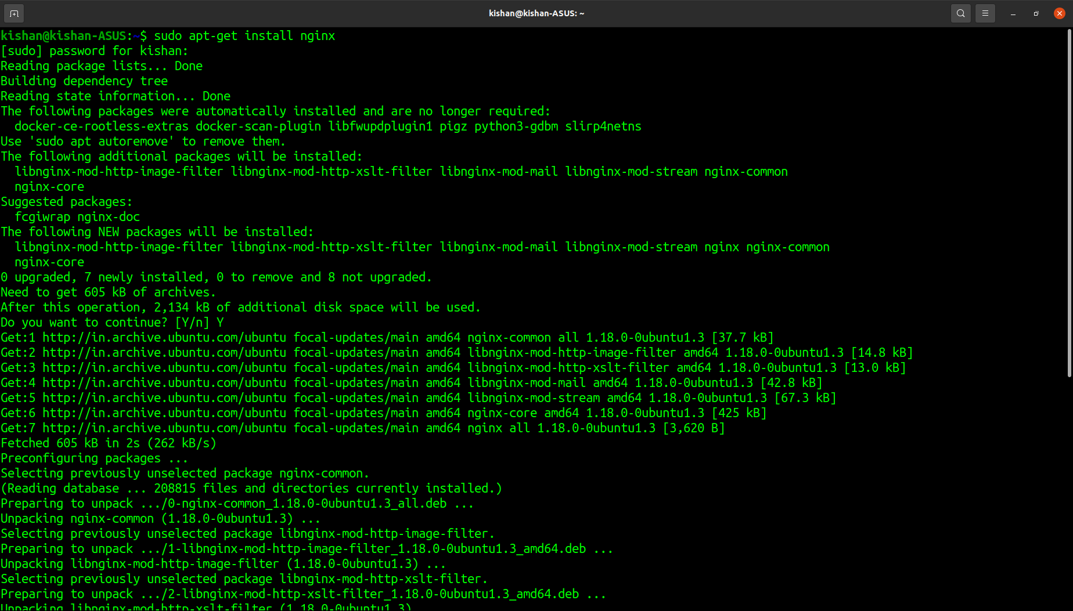

Checking Status after installation

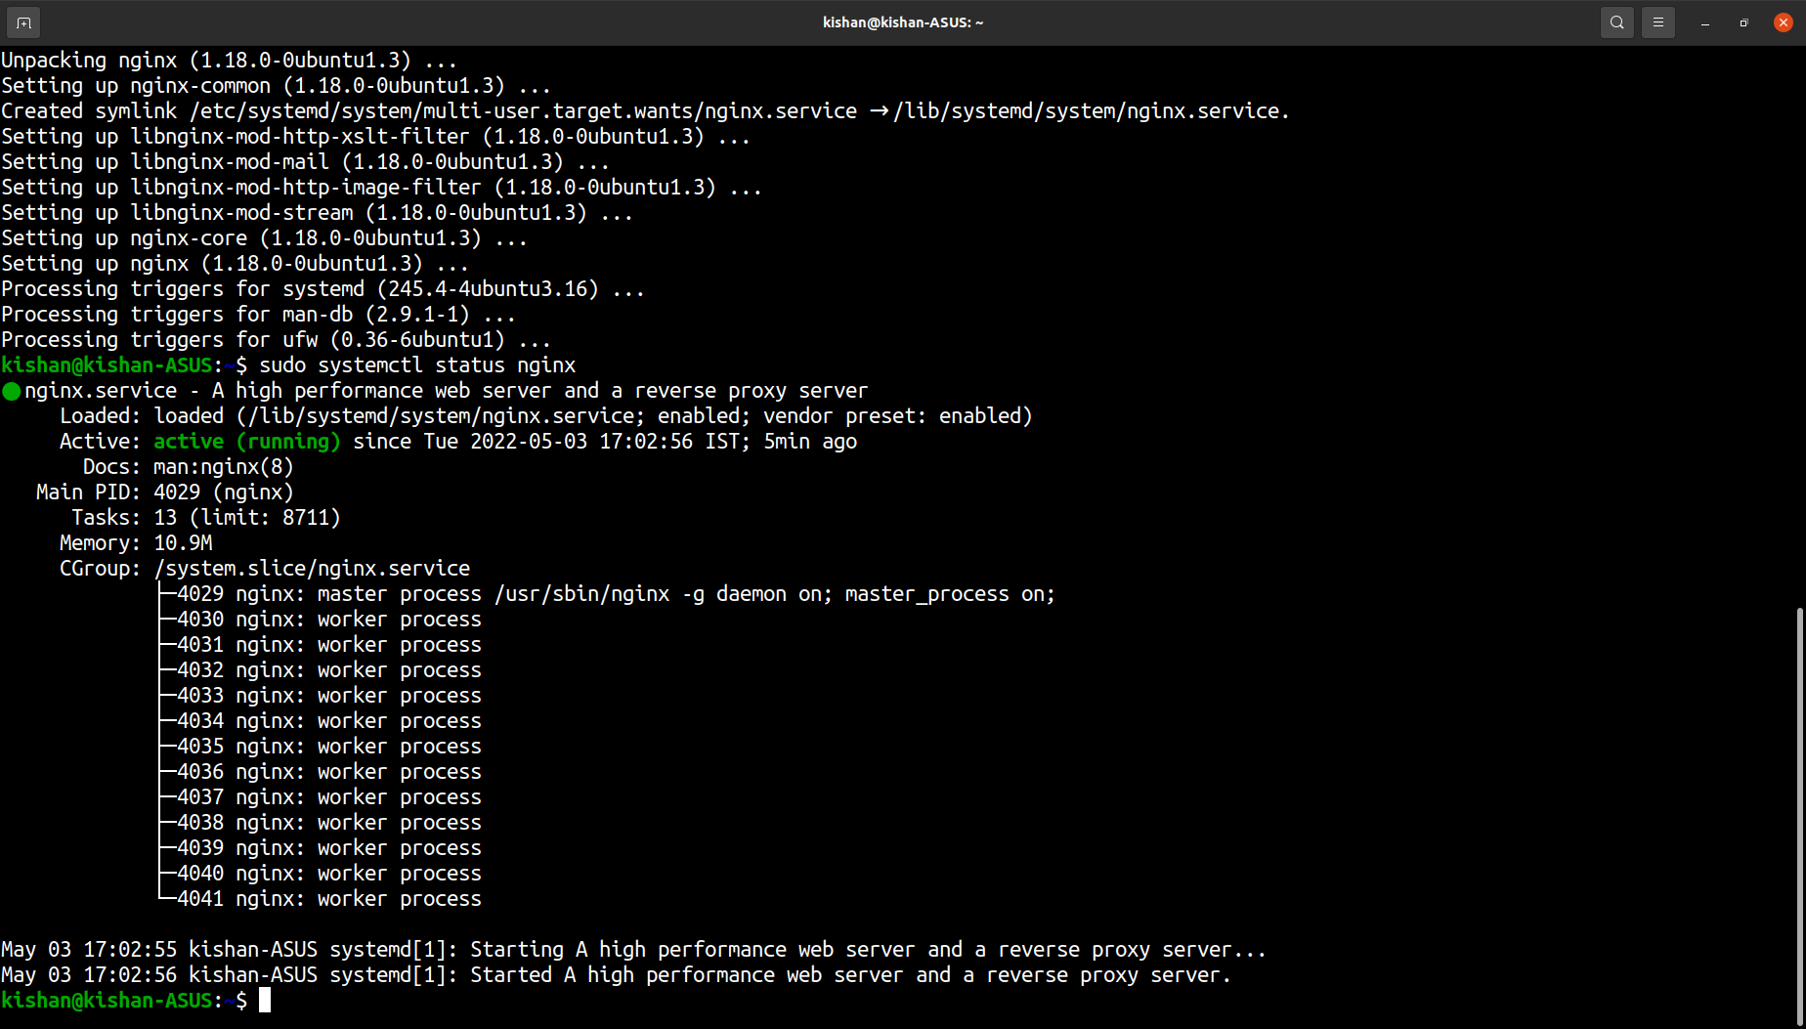

Curl(Client URL) on local host

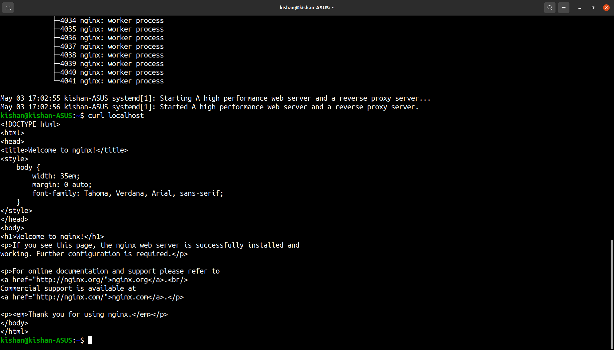

Welcome to NGINX(Successfully installed)

Checked on localhost(public IP)

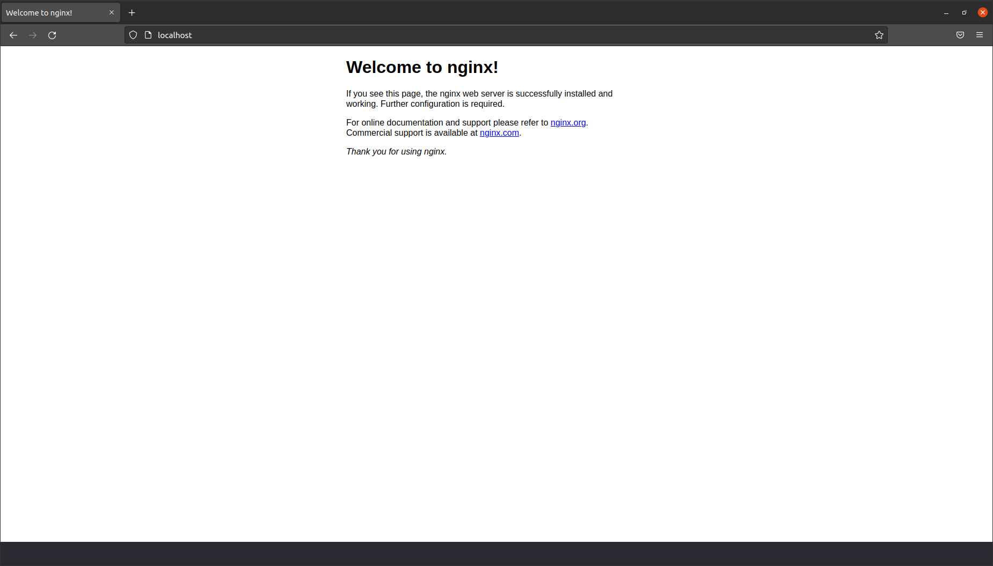

/etc/nginx (All files and configuration files related to nginx present in this directory)

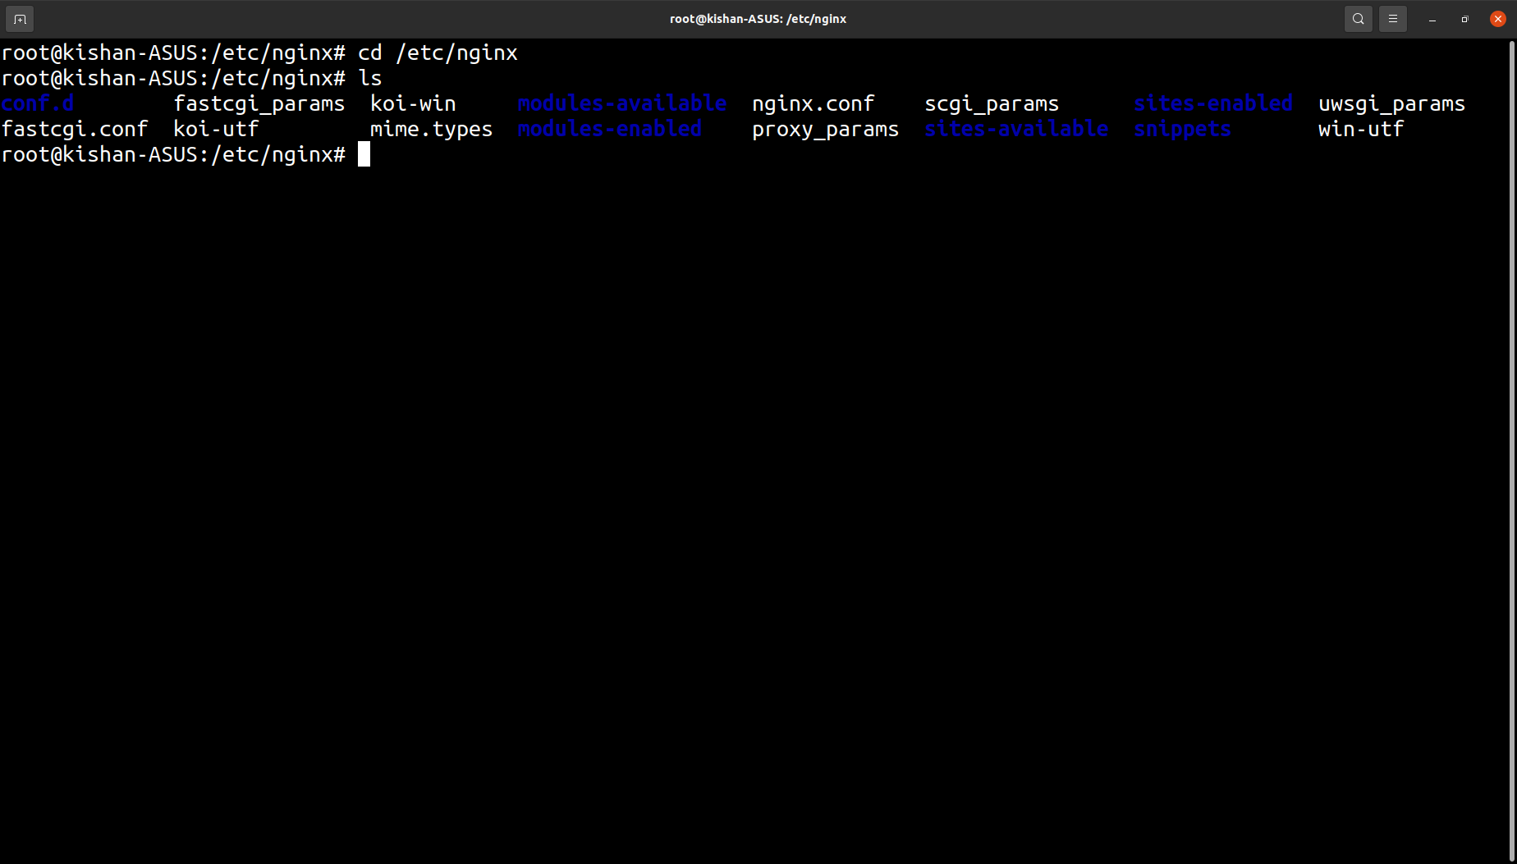

Default configuration file of nginx

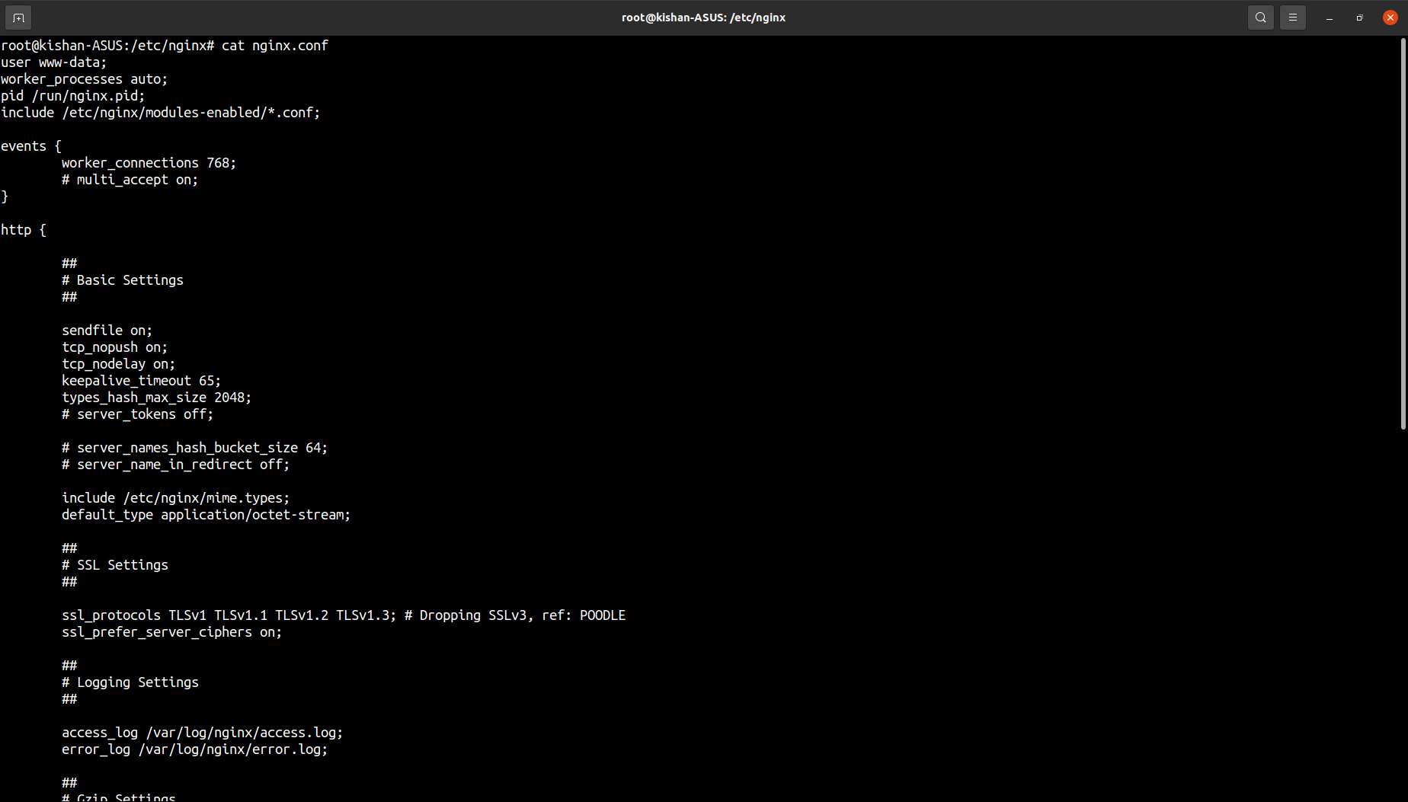

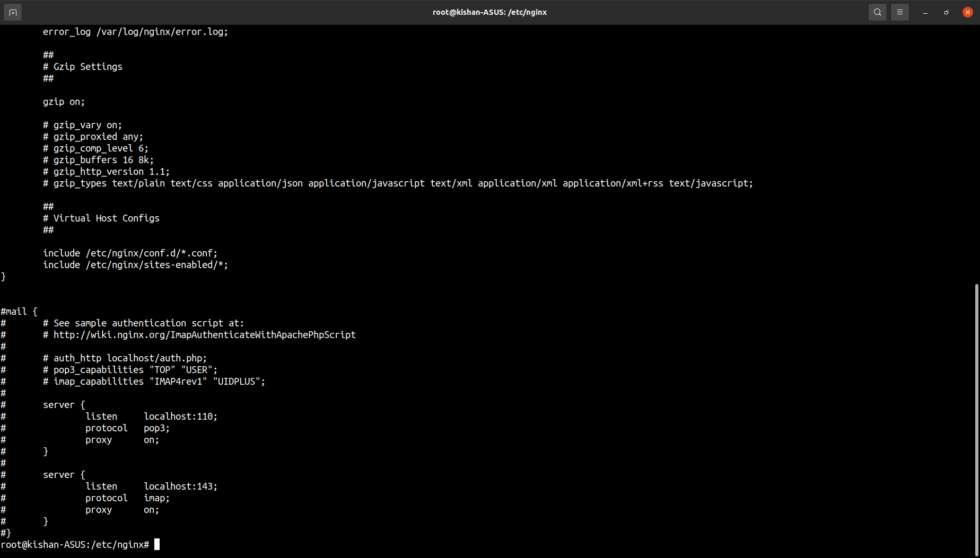

Default configuration file (Linked by default to conf)

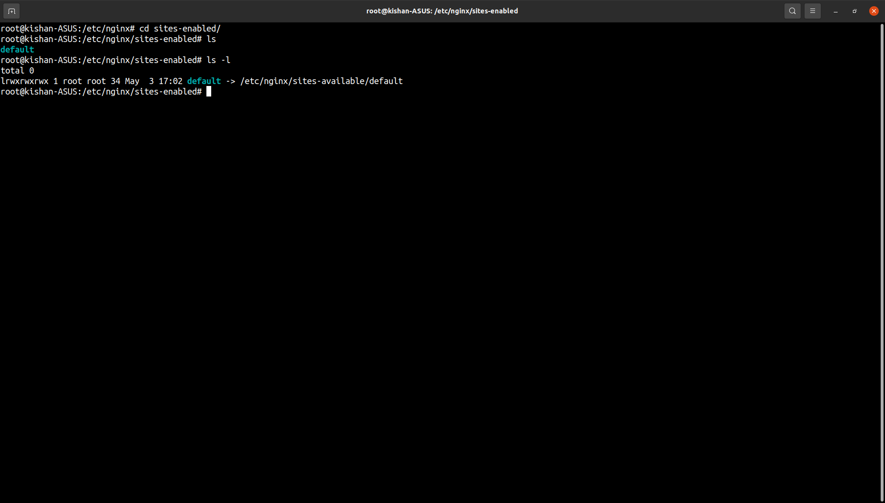

To write own custom configuration file unlink **default,** then write own conf file

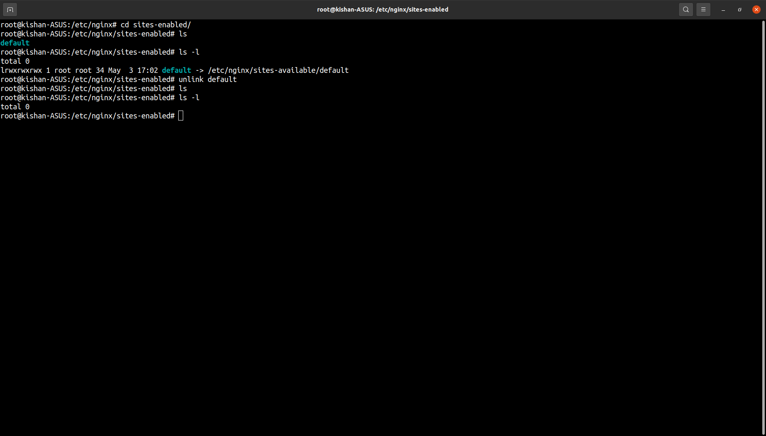

Created a custom configuration file

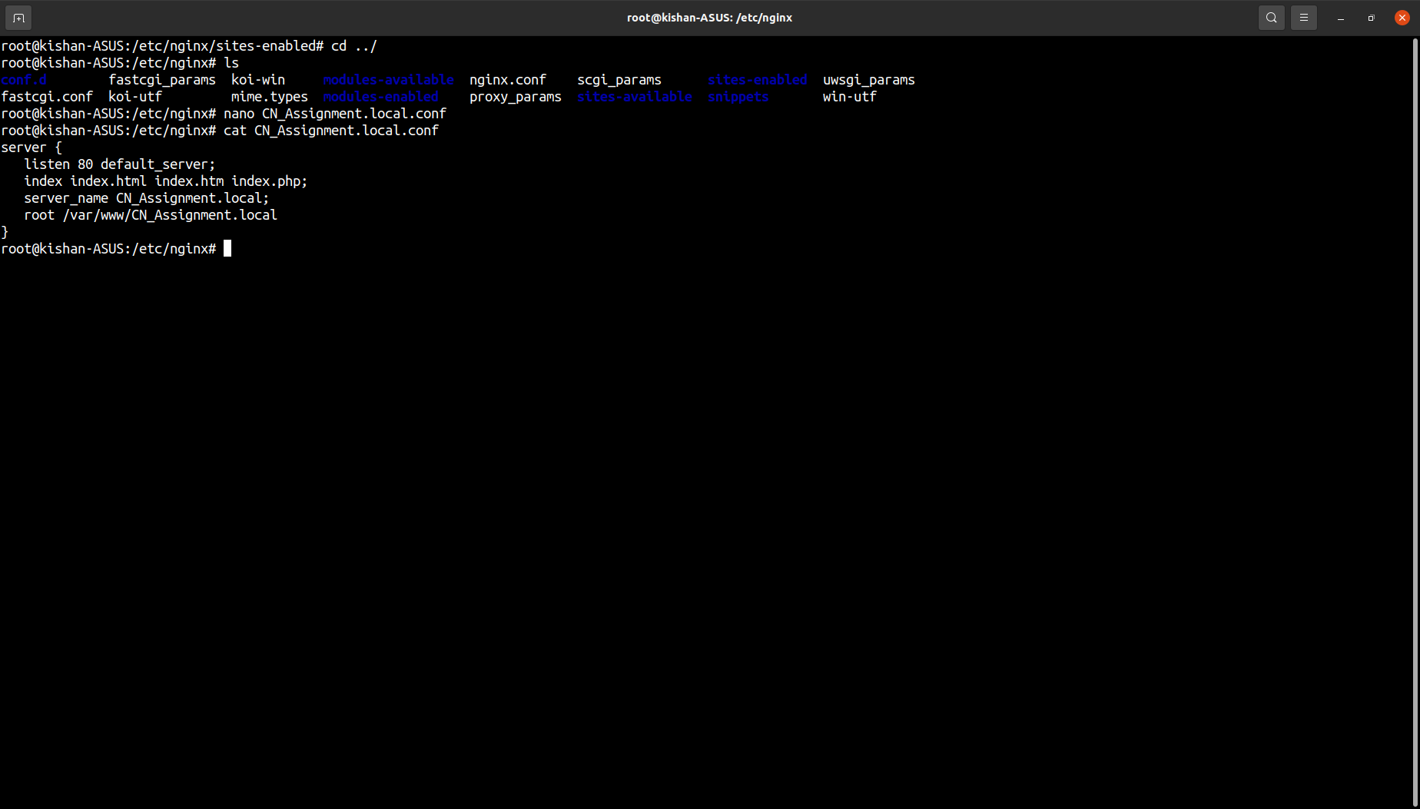

Checking if there was any error made when making conf files

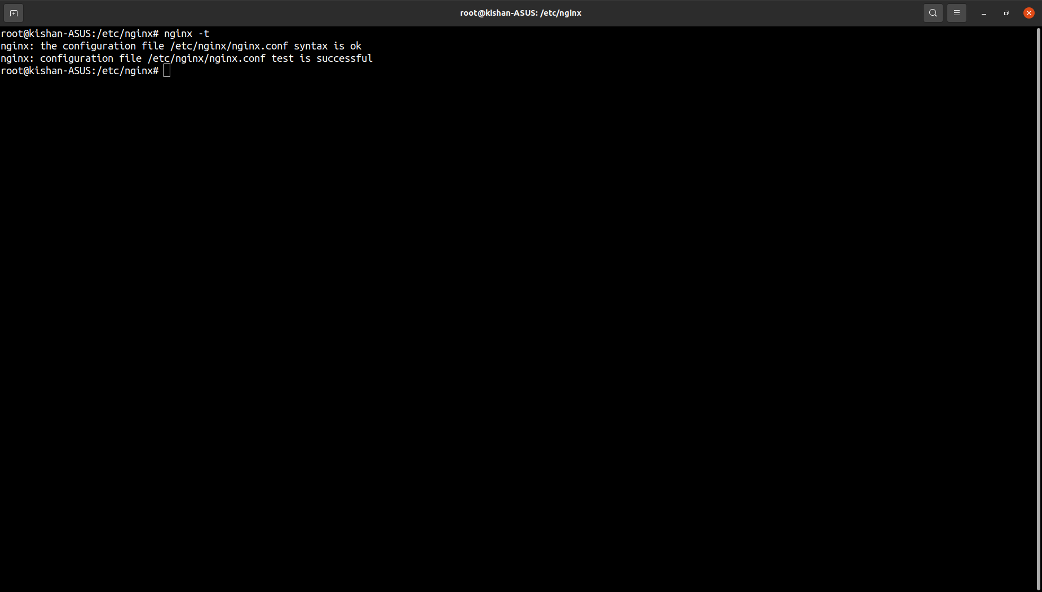

File serving default nginx page

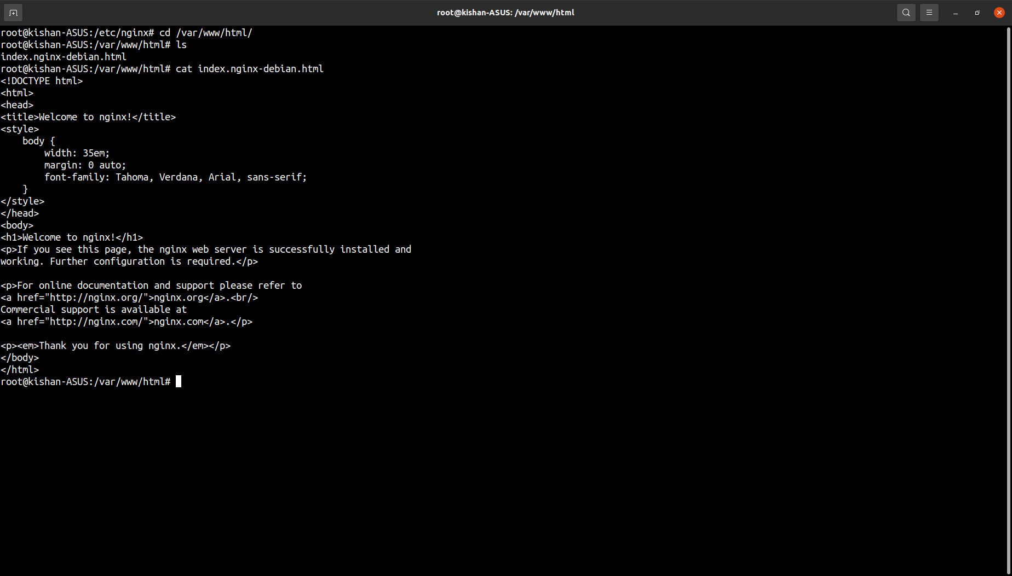

Creating custom page instead of default page (server Block other than default )

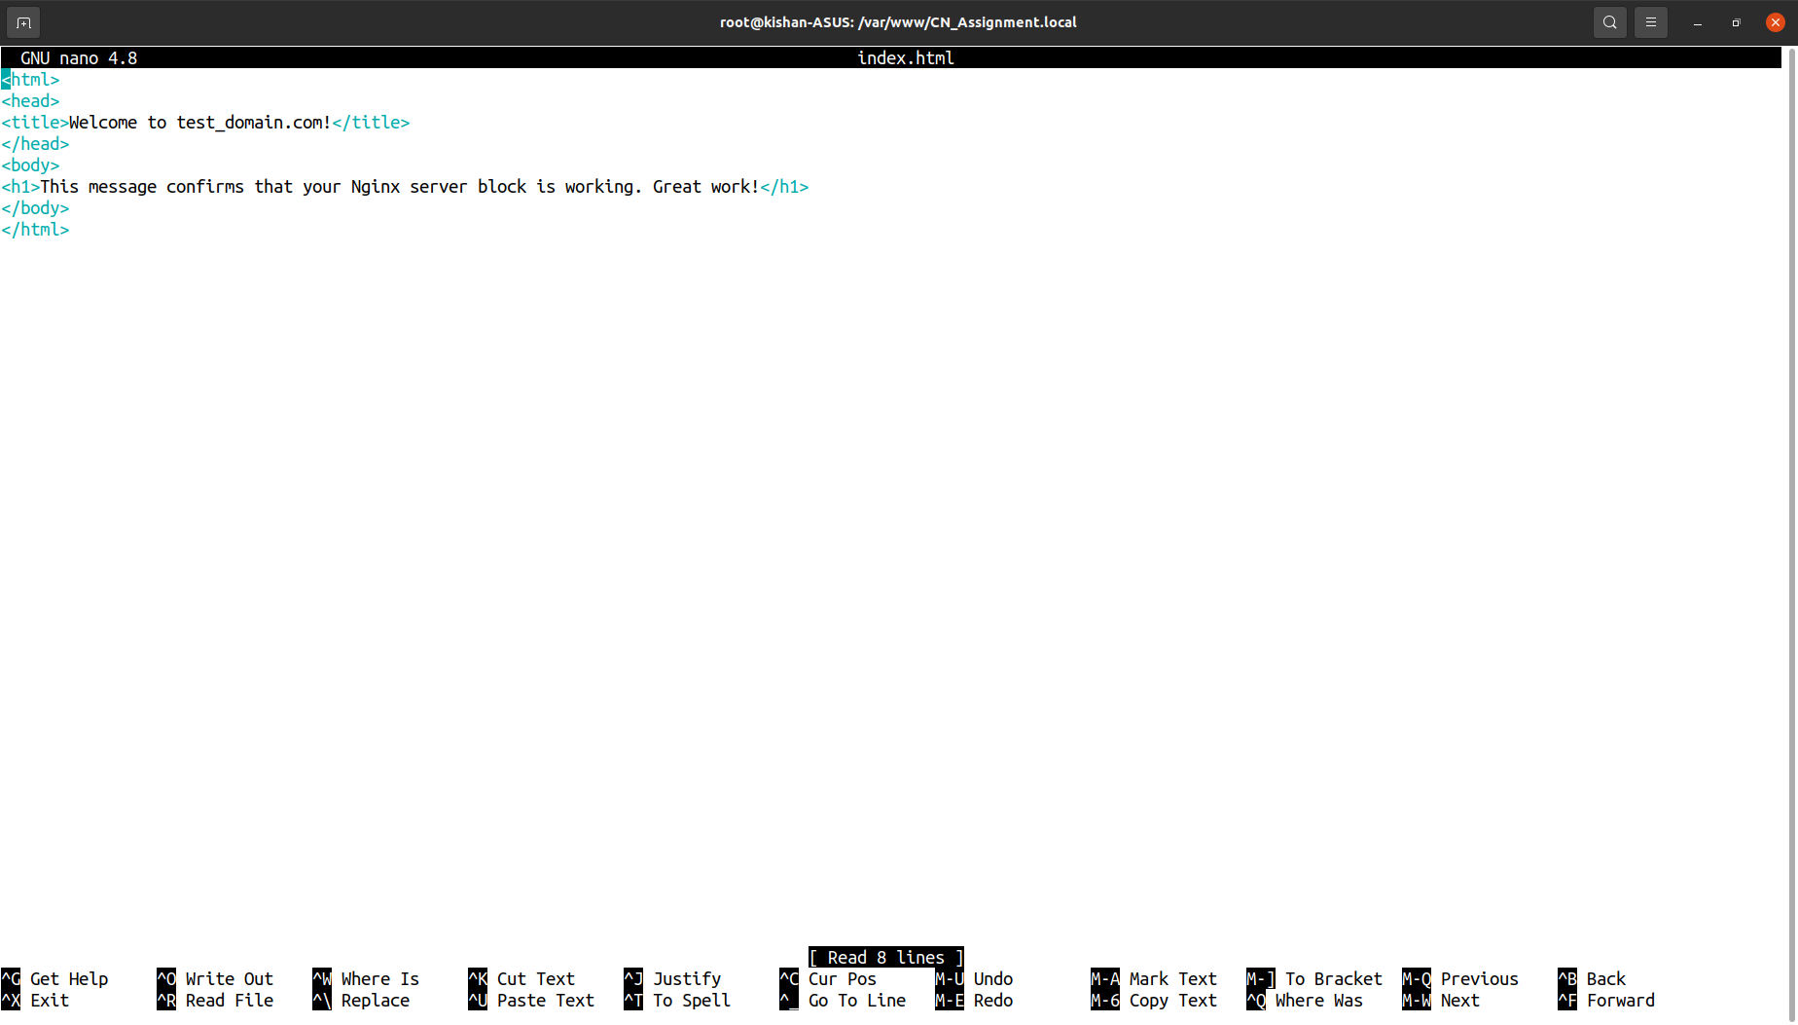

Now we reload nginx (reload to apply conf changes) and then reload the localhost(on web browser) which displays now our custom message (html file)

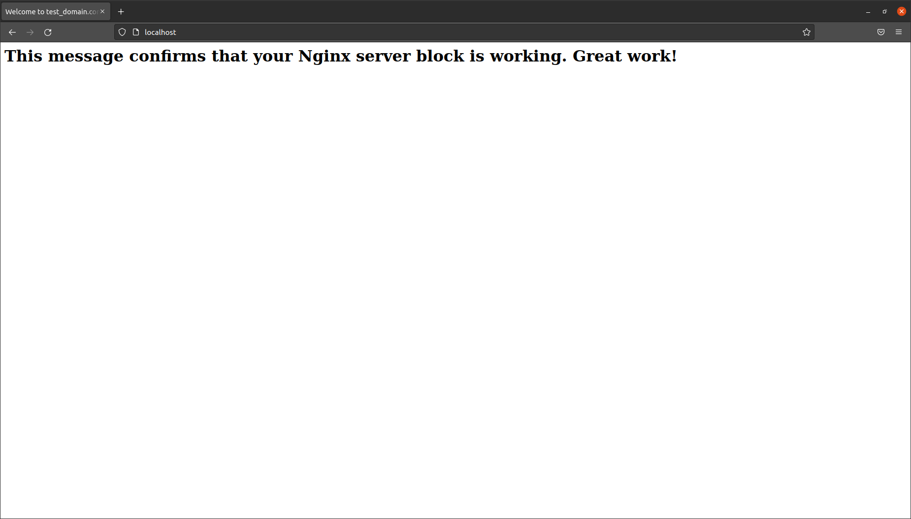

Created a custom page (host own websites etc)

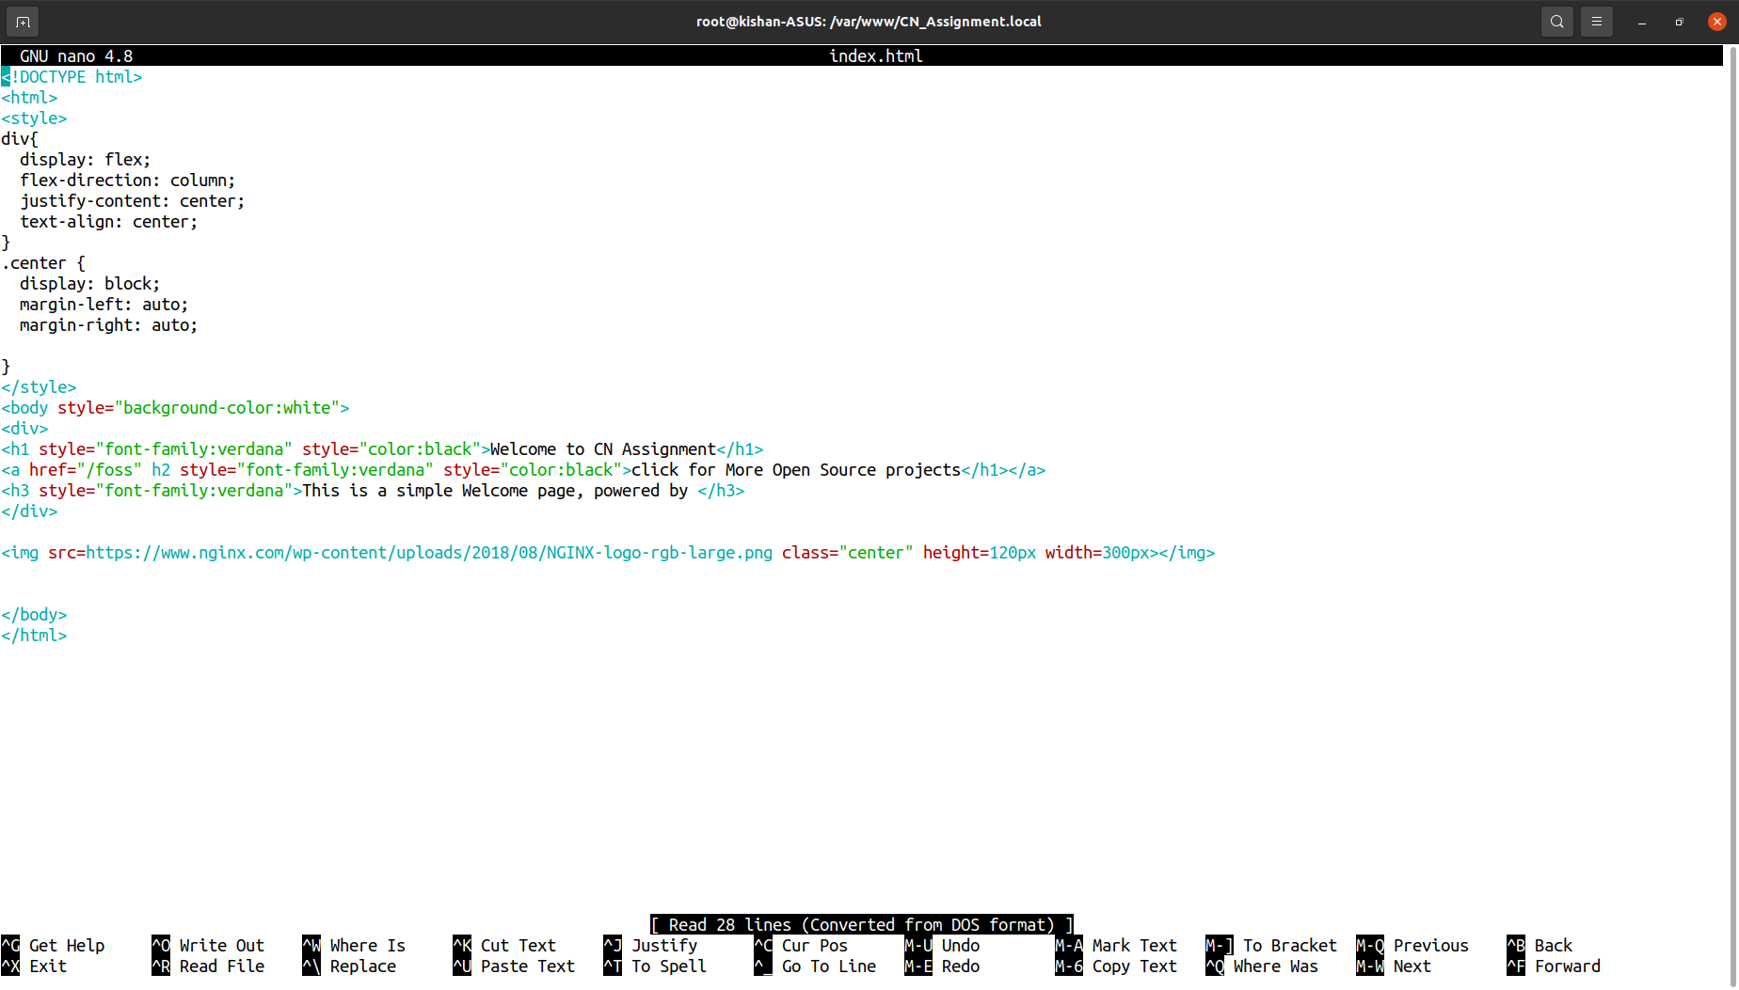

output

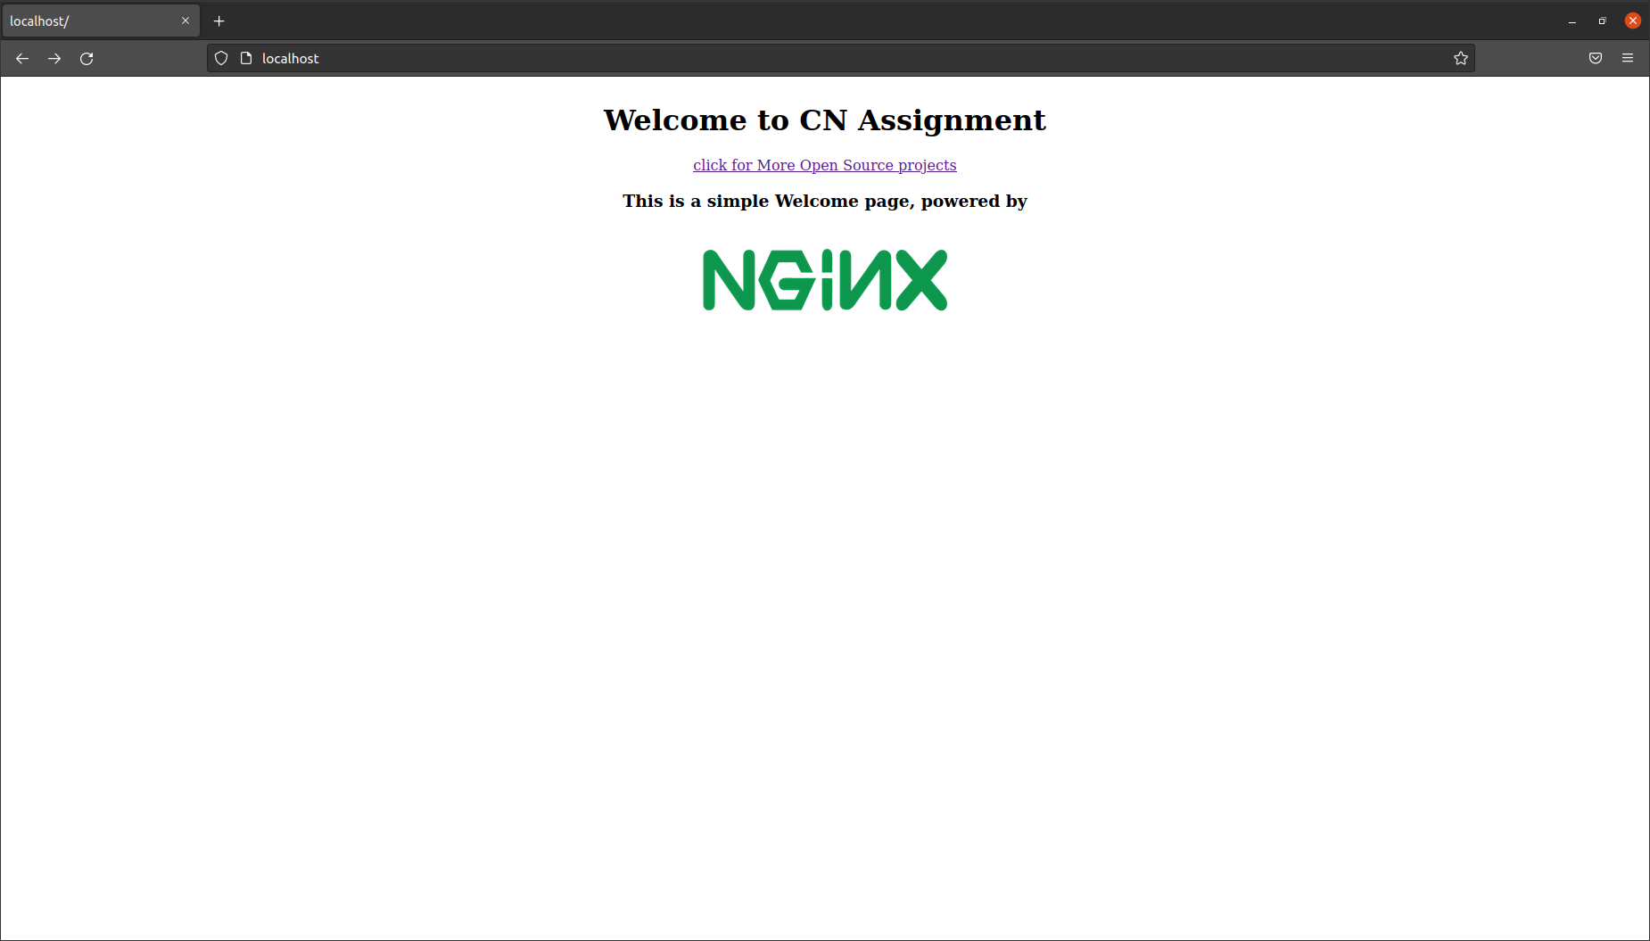

Giving a path in html document but not configuring in conf file of nginx so Error is displayed(4xx error that is client side error)

HTML Doc of foss

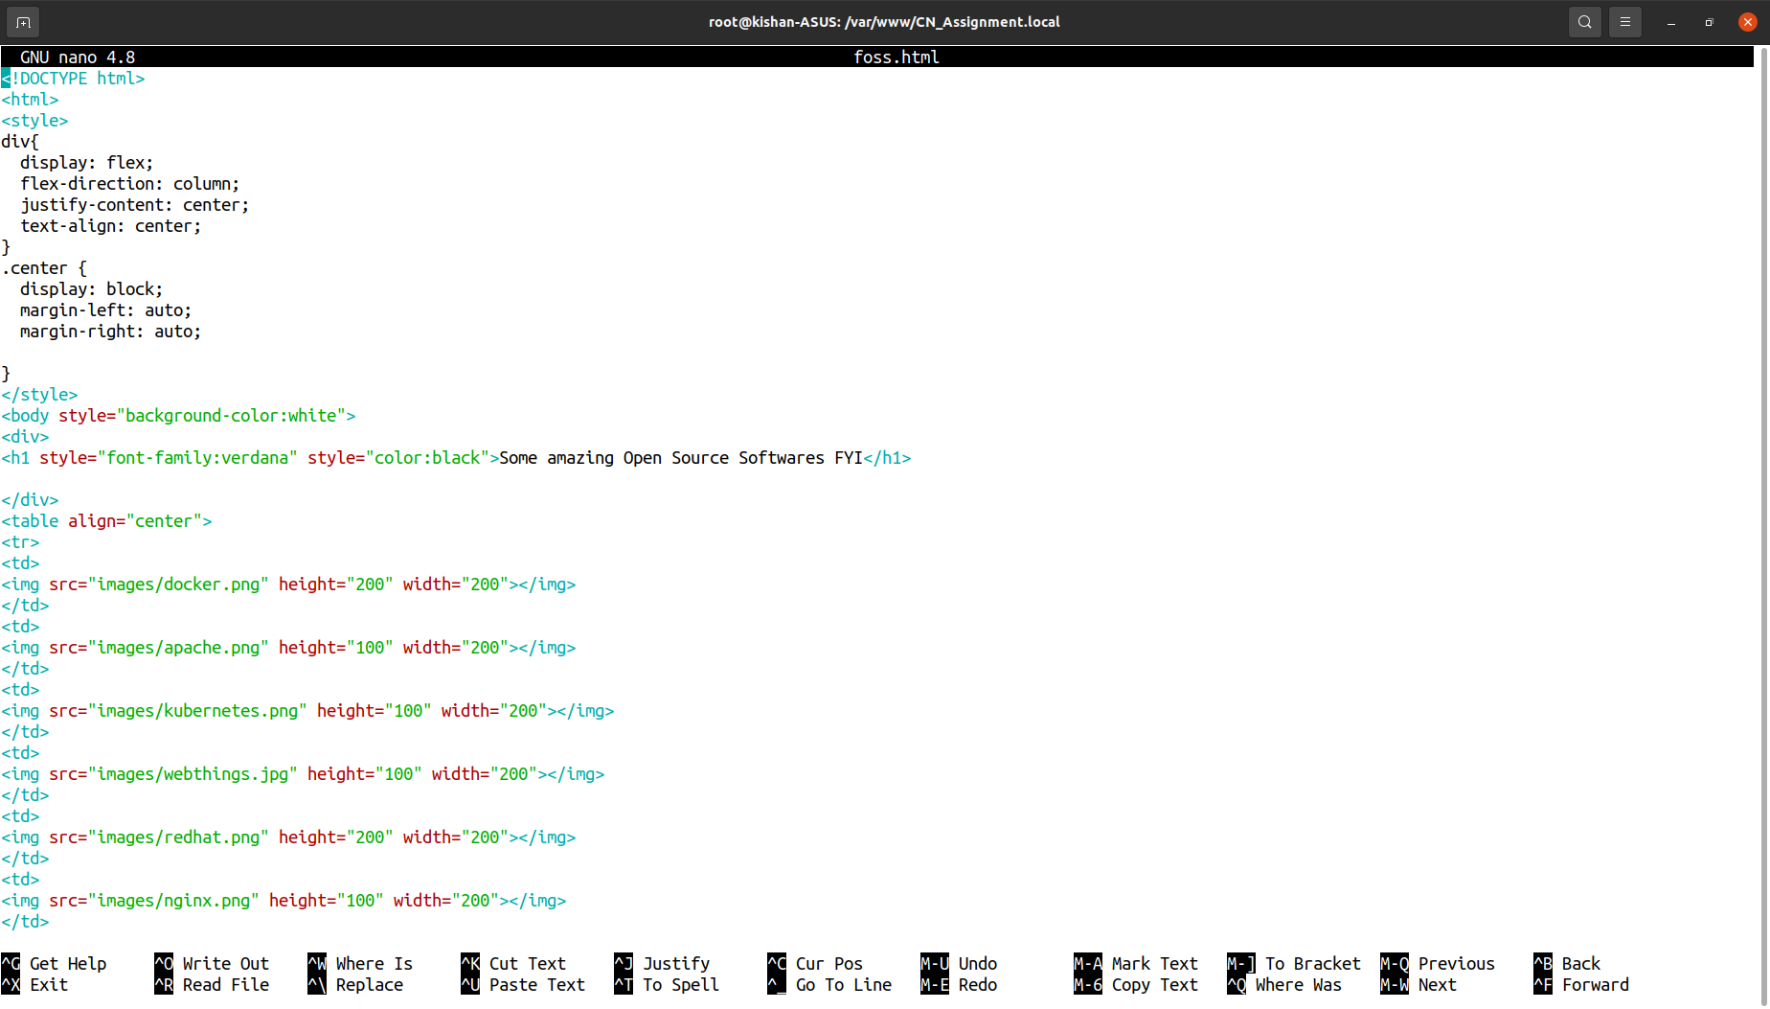

Output

404 (page exists but isnt served … configured)

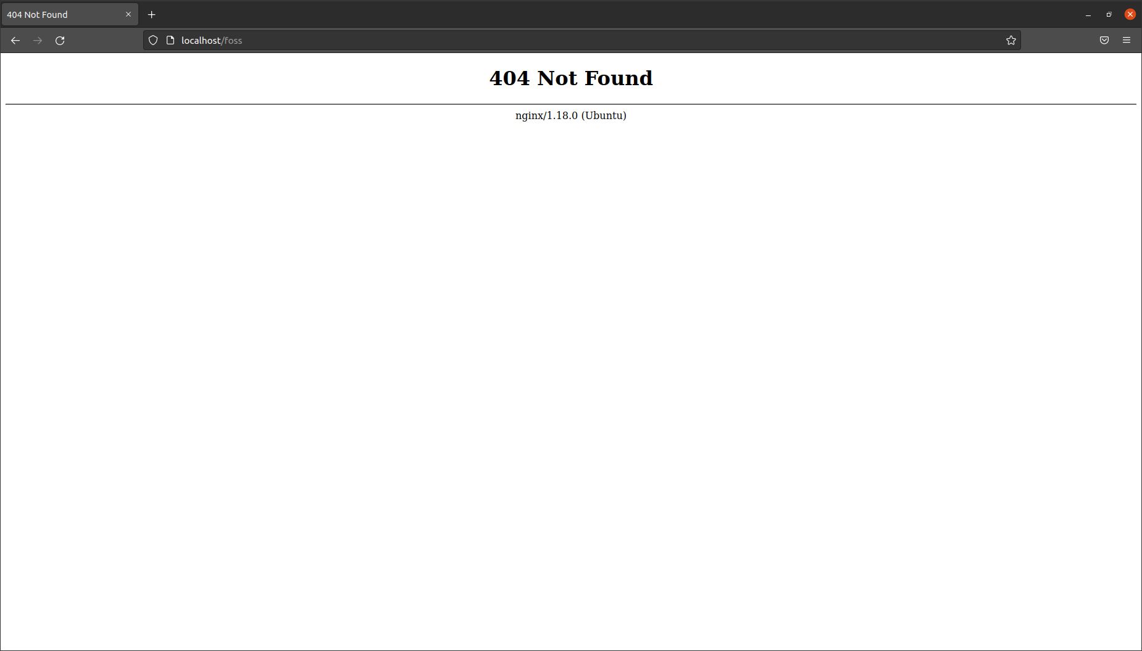

Configuring all requests in **default location** to check these folders or return 400 error if not found

And passing location / foss which is custom path for configuring foss.html file,nginx serves the file when user requests it.

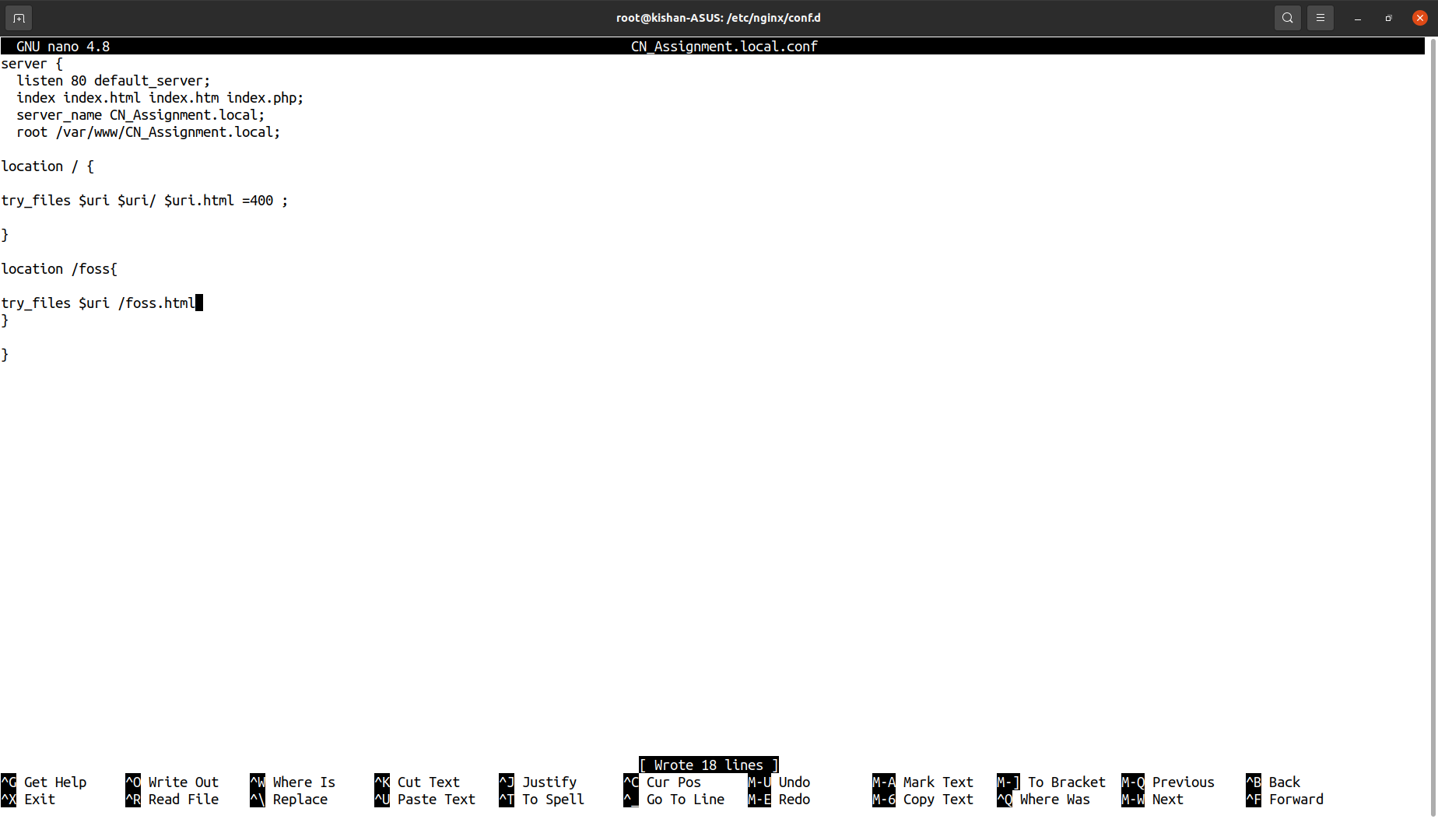

Output :

Reload to apply configuration changes and then reload the page which was showing 404 error



400 error (Bad request page doesn't exist at all)

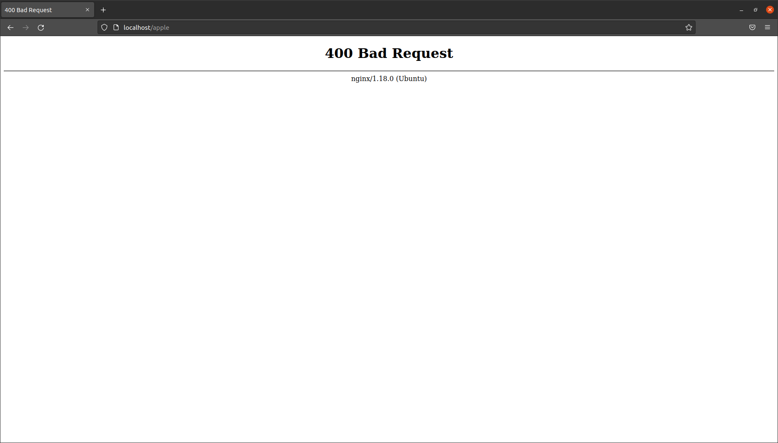

Custom error page (edit conf file and server custom error page through nginx)

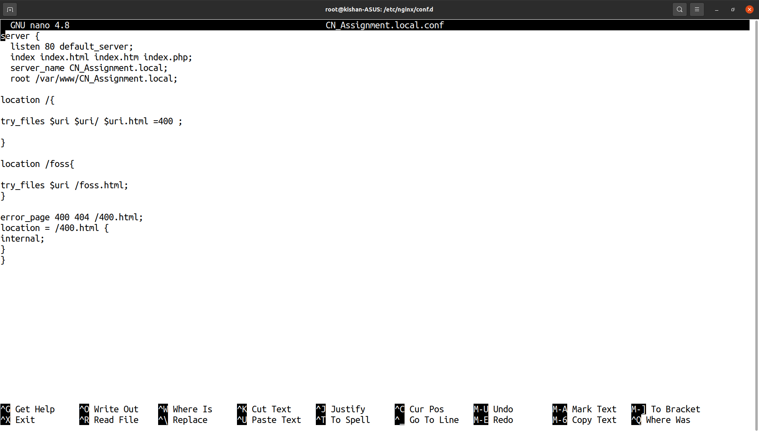

Output when browsing to non existing page

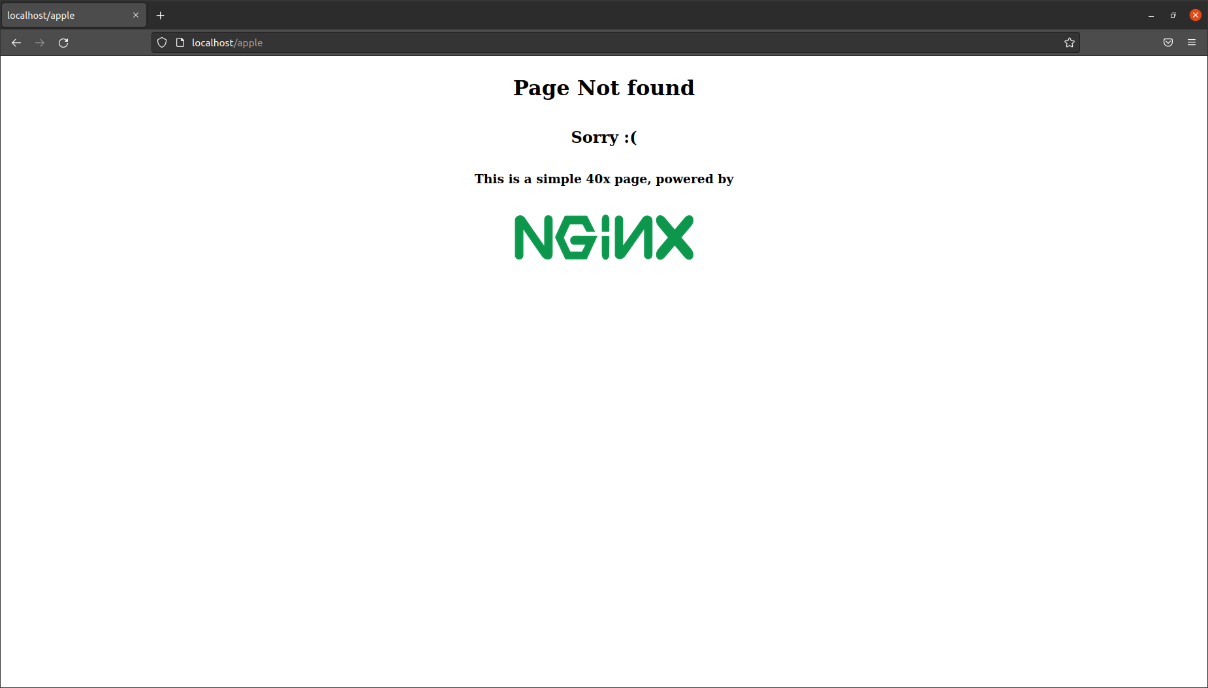

Issue with server (5xx errors)

Editing the conf file with location and the path to file 50x.html which will show when 5xx error occurs.

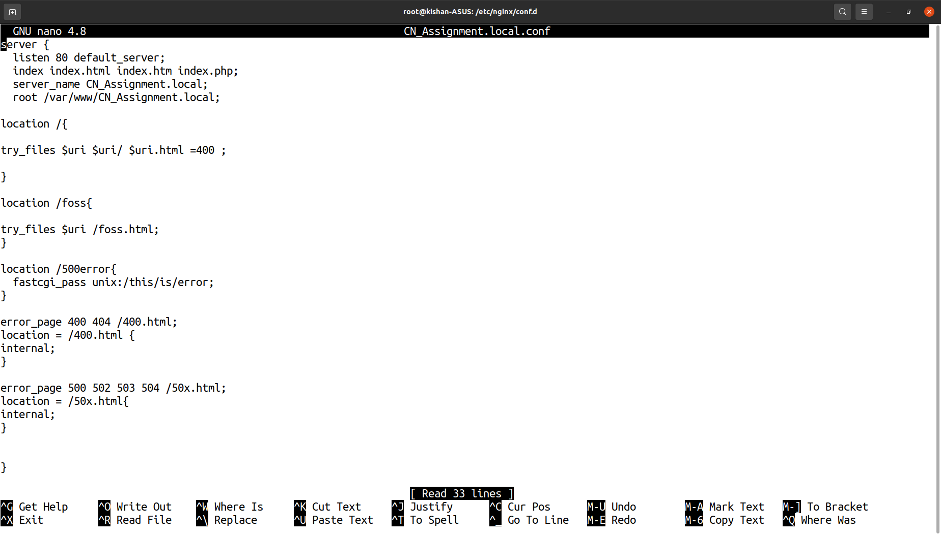

Output

